

AI Code Mentor – Project Report

Academic Task-3: Project (INT-428)

Submitted By:  
  
Name: Abhay Chaudhary, Mukund Khandelwal, Priyam Tiwari  
Registration Number: 12315216, 12316528, 12315493  
Roll No.: 41,42,1  
Section: K23GN

Submitted To:  
  
Dr. Ishan Kumar  
(April 2025)

# Table of Contents

1. Introduction

2. Problem Statement

3. Real-Life Use Case Example

4. Technologies and Libraries Used

5. Project Structure

6. Data Flow

7. Working Process

8. Security Considerations

9. Conclusion

10. Future Enhancements

11. Special Thanks

# 1. Introduction

AI Code Mentor is a web-based educational tool designed to help programmers of all levels improve their code by offering real-time syntax validation, error explanations, and code correction suggestions across multiple languages (Python, C, C++, Java). Unlike conventional compilers that only point out errors, this tool explains **why** the error occurred and **how to fix it**, fostering deeper learning and quicker debugging.

The project bridges the gap between code validation tools and beginner-friendly teaching platforms, making it ideal for students, educators, and developers looking to save time and reduce frustration.

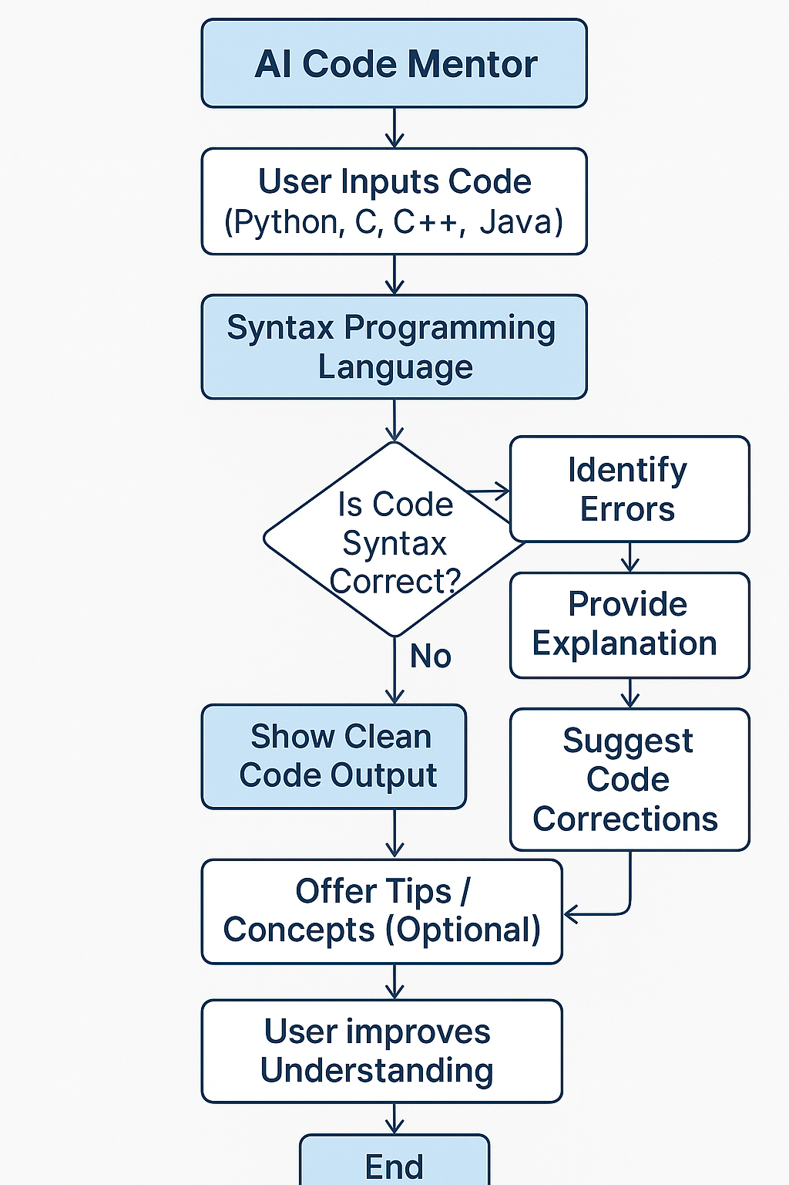

2. Problem Statement

Despite the presence of robust compilers and IDEs, coding still presents major difficulties for beginners and even experienced developers:

* Understanding compiler errors is difficult without prior experience.
* Traditional tools do not offer **guided corrections** or **intelligent explanations**.
* Setting up environments for compiling C/C++ or Java is time-consuming.
* There is a lack of **language-agnostic** tools that work across multiple platforms.

**AI Code Mentor** addresses these problems with a smart, unified interface that:

* Offers **language-aware compilation and validation**.
* Returns **easy-to-understand explanations**.
* Suggests **auto-corrected code** for common issues.
* Works **fully inside a web browser**.

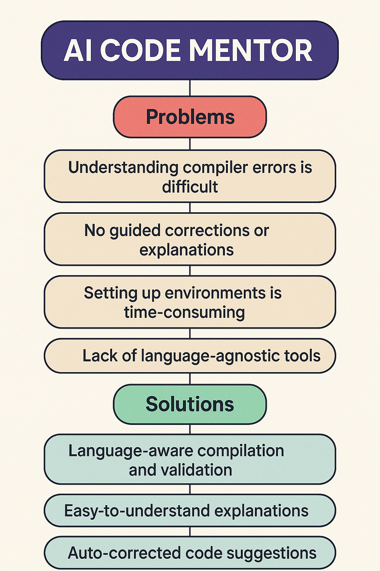

# 3. Real-Life Use Case Example

Imagine a student in their first semester working with C++. They write:

#include <iostream>

using namespace std;

int main() {

cout << "Hello World"

return 0;

}

Instead of a cryptic compiler error, AI Code Mentor responds with:

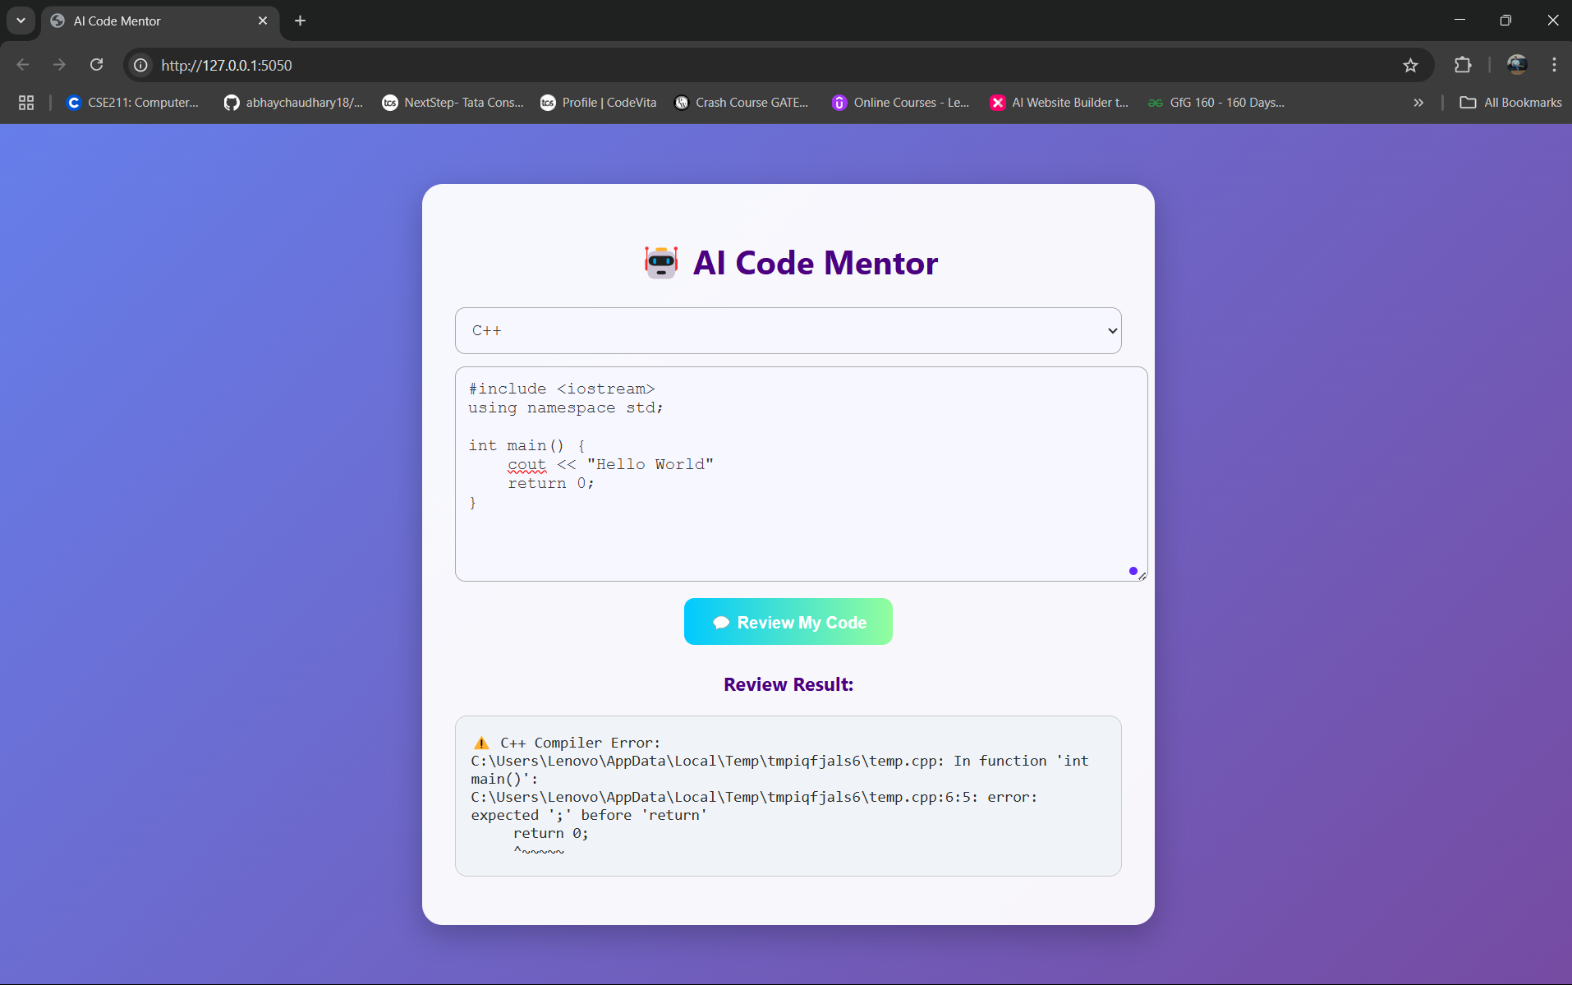

4. Technologies and Libraries Used

The following technologies are used to power this intelligent platform:

* **Flask**: Lightweight Python framework for creating the web API and routes.
* **Subprocess**: Executes system compilers securely for C, C++, and Java.
* **Tempfile & OS**: Manages temporary files for submitted code.
* **Platform**: Detects the operating system to configure compilation commands.
* **Regex**: Extracts class names for Java files and applies transformations.
* **HTML/CSS/JavaScript**: Powers the responsive and intuitive frontend.
* **Python compile()**: Used for lightweight Python syntax validation.

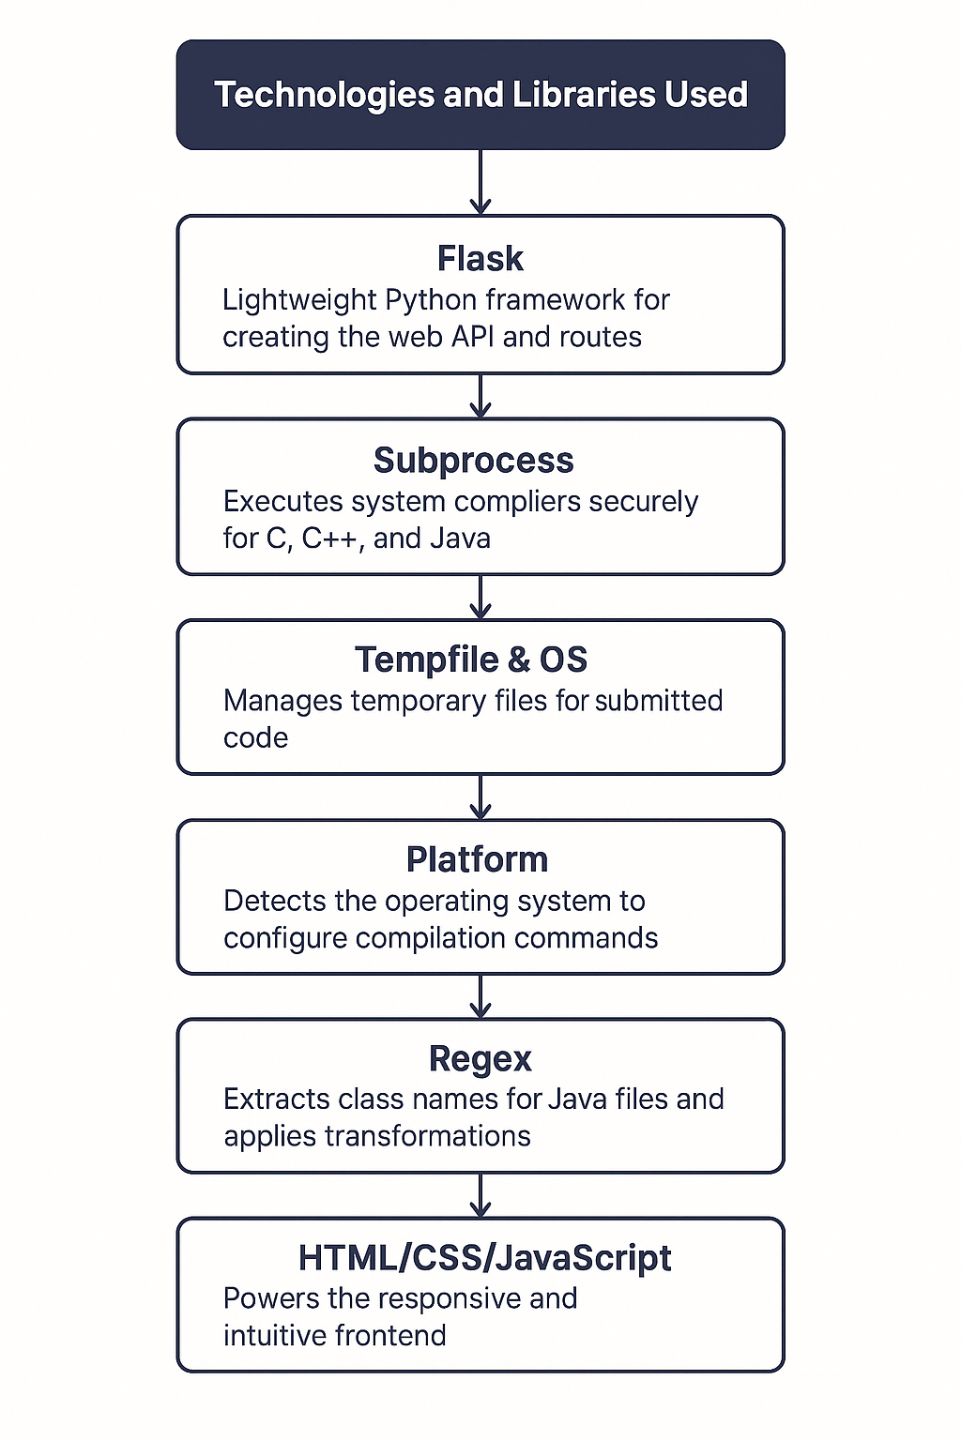

5. Project Structure

The system is modular and scalable:

- app.py – Main server code handling routes, compilation, and error analysis  
- HTML Interface (returned by '/') – Provides dropdown, textarea, and live result display  
- JavaScript Logic – Sends code to server using Fetch API and updates result dynamically  
- Temporary Files – Source code is stored in temp files and compiled on the fly  
- Error Parsing Logic – Generates human-friendly messages based on compiler output

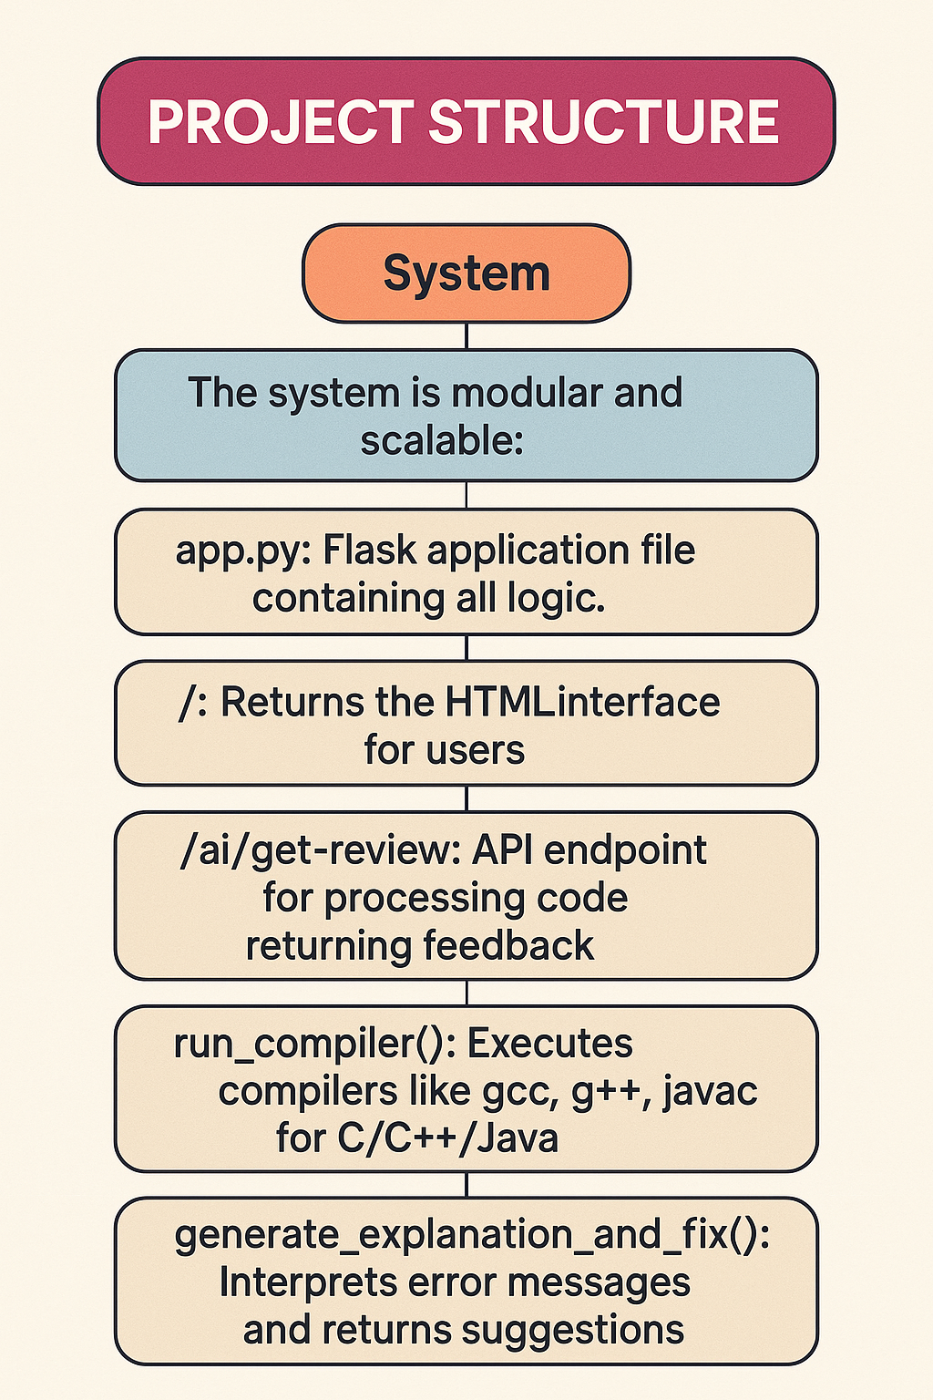

6. Data Flow

**Architecture:**

1. **Frontend**:
   * User selects language and pastes code.
   * AJAX request sends code to Flask backend.
2. **Backend (Flask)**:
   * Receives the code and language.
   * Saves code to a temporary file.
   * Executes relevant compiler or interpreter.
   * Parses the output or error.
   * Returns detailed explanation + fixed code (if possible).
3. **Compiler Layer**:
   * Python: uses compile()
   * C/C++: uses gcc / g++
   * Java: uses javac after editing class name

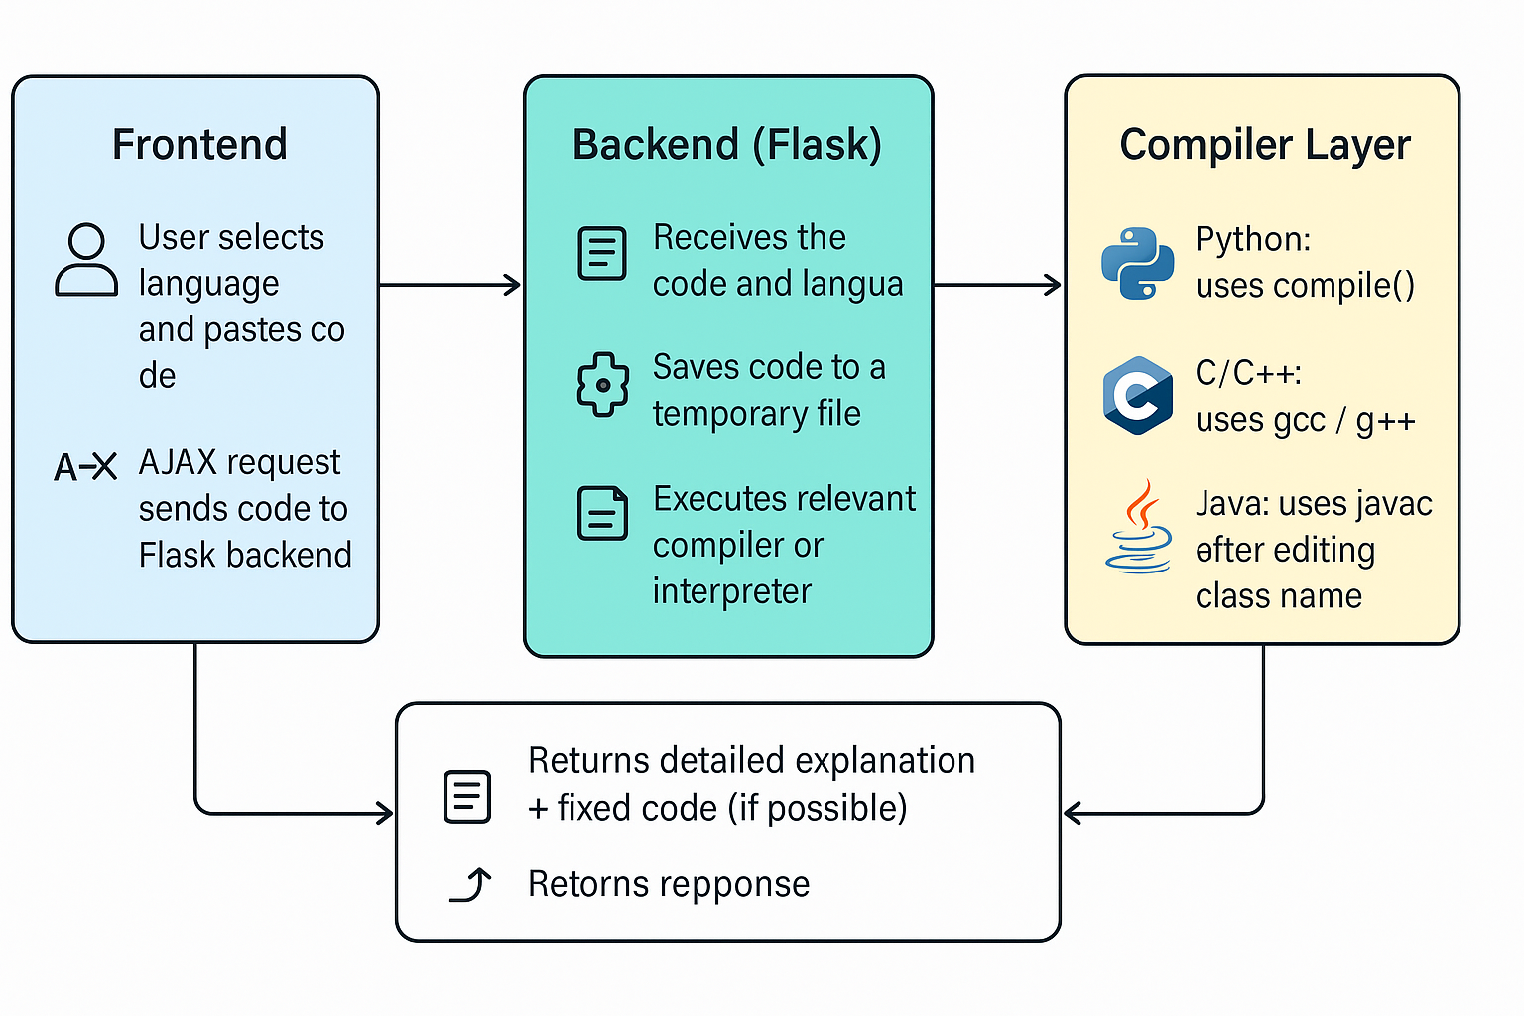

# 7. Working Process

- The user interacts with the interface as follows:

* **Step 1**: Selects programming language
* **Step 2**: Pastes code and clicks "Review My Code"
* **Step 3**: Backend identifies syntax errors or success
* **Step 4**: Explanation and correction are generated
* **Step 5**: Results shown in formatted blocks in the browser

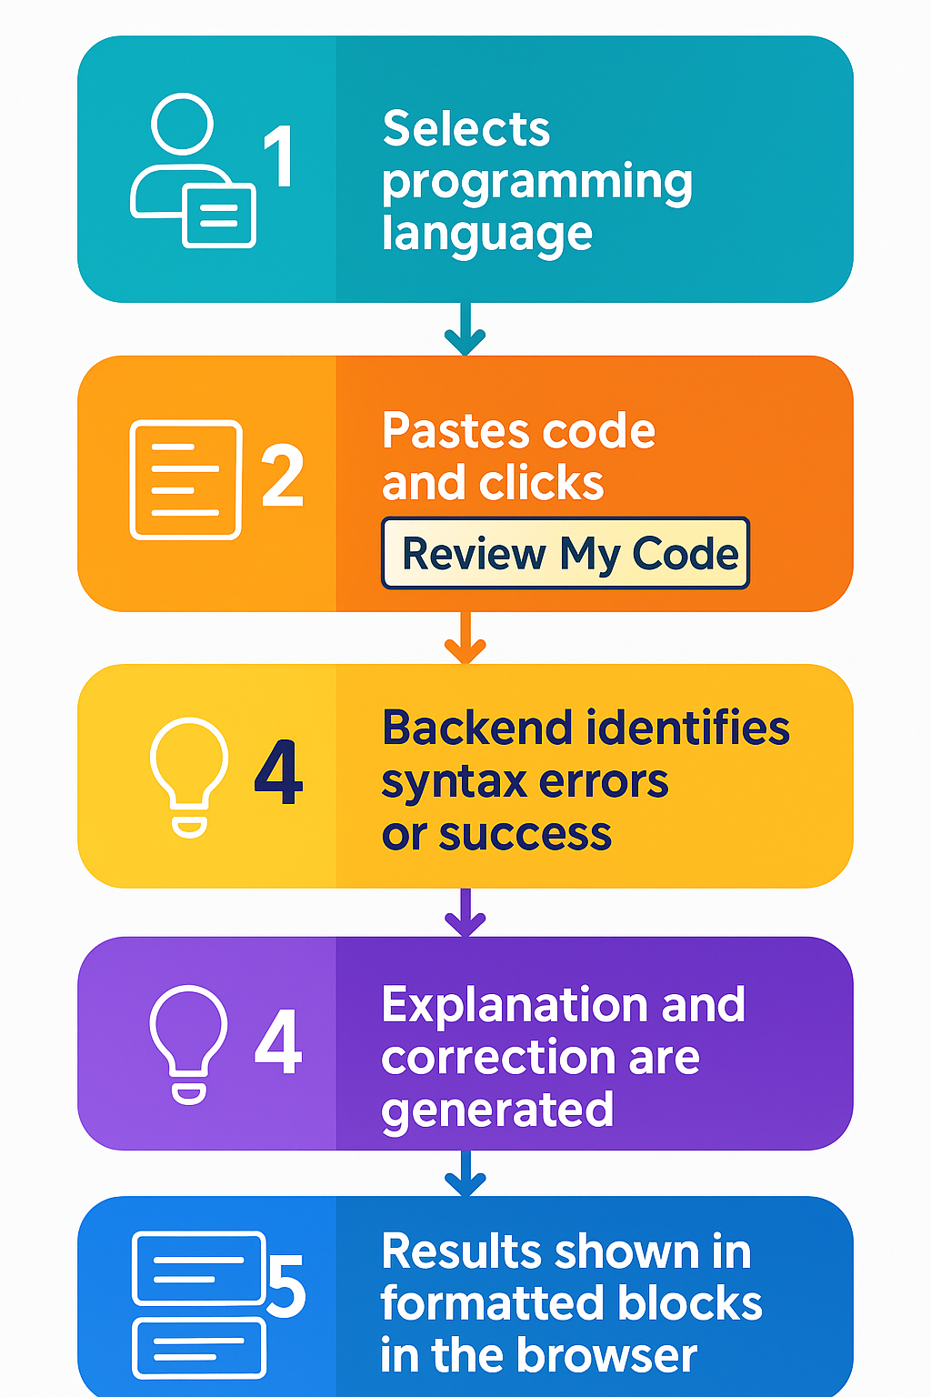

# 8. Security Considerations

• No actual code execution is done — only **syntax checking**.

• Temporary files are deleted immediately after each session.

• Compiler commands are **sanitized** to avoid code injection.

• Subprocesses have **timeout limits** to prevent infinite loops.

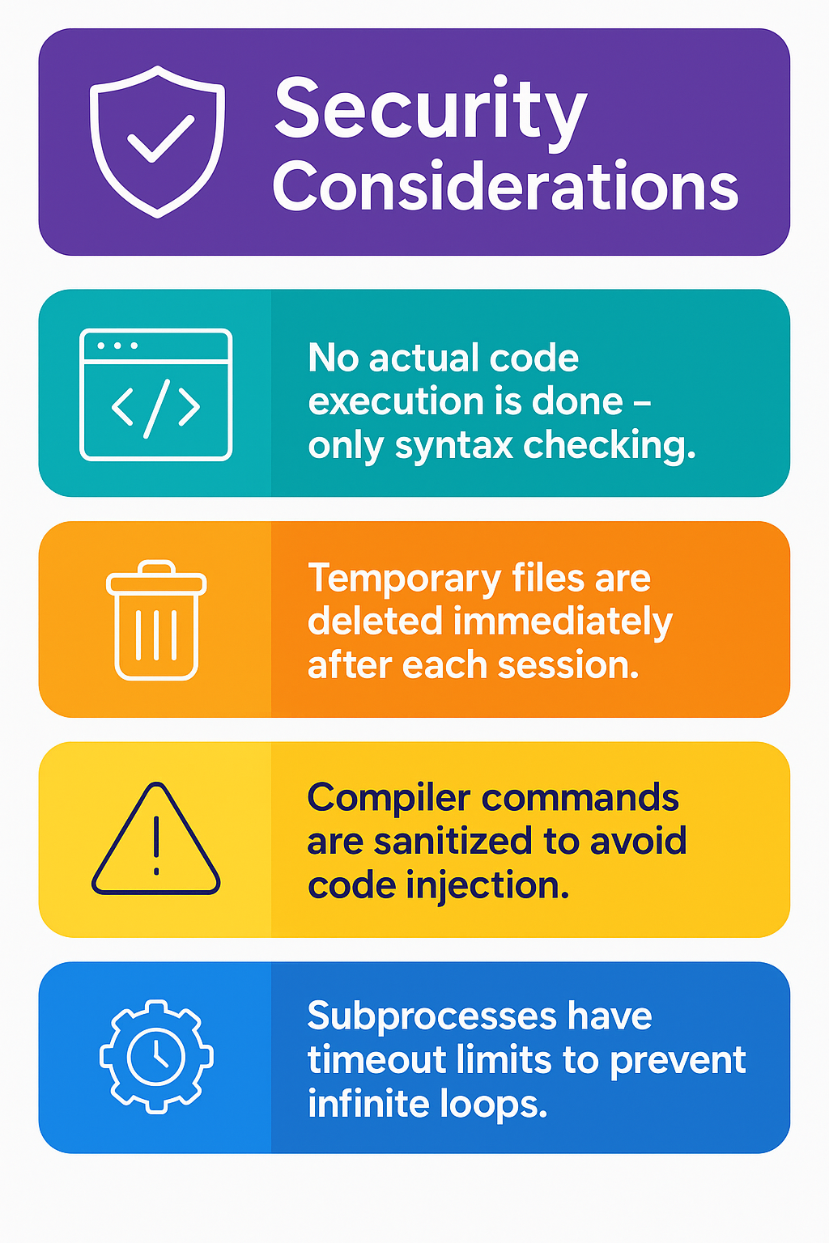

9. Conclusion

AI Code Mentor introduces a novel approach to helping programmers through intelligent code validation, language-specific explanations, and actionable corrections. It reduces the entry barrier for new developers and increases productivity for experienced ones.

Its architecture ensures security, simplicity, and extensibility, making it a strong foundation for an educational or commercial tool.

# 10. Future Enhancements

- Code Execution: Run programs in a sandboxed environment  
- AI-Powered Explanations: Integrate with GPT-4 for smarter corrections  
- Support More Languages: Add support for JavaScript, Rust, etc.  
- User Accounts: Allow users to save and share their code  
- Live Editor: Highlight syntax and errors as the user types

11. Special Thanks

• **Dr. Ishan Kumar**, for academic guidance

• **Open-source developers**, for creating essential libraries and compilers

• **Friends and testers**, for supplying diverse test cases and feedback

• **The Python community**, for extensive documentation and modules